OKLAHOMA BUSINESS ETHICS CONSORTIUM
Oklahoma City Chapter ~ SEPTEMBER 26, 2007
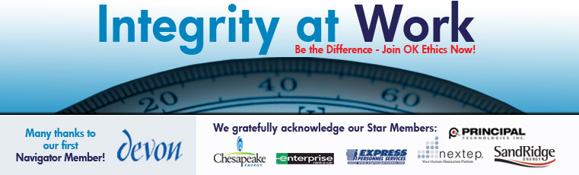

- KUDOS Shannon Hiebert, Vice President of Human Resources, Enterprise-Rent-A-Car & President of OkEthics
Guiding Principle: HONOR We express gratefulness to our hosts, sponsors and speakers.

  - Janice Dobbs of Devon Energy for her initiative in becoming OkEthics first Navigator ($7500) member!
  - PR Team Members – Marissa Callendar (Irwin Insurance), Marian Combs (OBU International) David Kimmel (SandRidge Energy) Justin Meek (Cicero International), Blaine Rider (Digital West), Kathy Oden-Hall (Dell) Chad Stanley (Express Personnel),
  - Kelli Schneider for actual “hands-on” development of our new marketing materials – many late nights & extra hours.

SPEAKING OF PR - -RENEW BY OCTOBER 22 AND BE FEATURED IN NEW BROCHURES!

  - Bob Byrne of Boeing for his extraordinary efforts in coordinating this milestone event, but for his work with OkEthics Foundation.
  - Greg Byers – Sinclair Broadcasting Group – Registration Chair – Epitomizes diligence & dependability!
  - Mary Kay Huggard & the team from Principal Technologies for their dedication & availability in handling the registrations!
  - Pam Fountain – Principal Technologies for making her great staff available to help us!
  - Joshua Jantz for his endurance in preparing and organizing our name tags.
  - Colin Autin – Oklahoma Accountancy Board for CPE’s & evaluation forms. Assisted by Naiman Bond and Donita Graves.
  - Connie Barwick – Maximum Multi Media Creations for the pre-meeting Power Point presentations.
  - Website Transition Team – Connie Barwick and Kellian Schneider, Consultants “Extraordinaire” Look for something new soon!
All our outstanding volunteers including the Express Personnel team who helped with pre-meeting items!

- Acknowledgement of Special Guests
Bob Byrne, Ethics Advisor – Boeing, OkEthics Foundation President
  - Tom Daxon for extra efforts in recruiting our guests
  - Oklahoma legislators (both past and present)
  - Rebecca Adams – Oklahoma Ethics Commission
  - Enterprise Rent-A-Car for loan of office and phone to assist us in recruiting efforts.
  - Mike Strong – Oklahoma Quality Award Foundation
The “force” behind the OkEthics Compass Award!
  - Tulsa friends hosted by SpiritBank – Mary Smith & Royce Kelly
  - All our sponsors for their enthusiastic support of this initiative!

III. UPCOMING EVENTS Shannon Warren, OkEthics Founder & Acting Director
Advance reservations required for all events ~ Visit our website at www.okethics.org or
call 858-2233; Member discounts apply regardless of location.
Norman Chapter
NOTE: Members of the Oklahoma Business Ethics Consortium frequently share information concerning various issues and developments that may have legal implications. The discussions, commentary, and handouts at Consortium meetings or presentations to other organizations are for general informational purposes only. They cover only some aspects of the subject topic, and do not constitute a complete legal analysis of the topic or how it might apply to any particular set of facts. Before taking any action based on information presented by a Consortium member, participants are encouraged to consult a qualified attorney. The observations and comments of presenters at Consortium meetings and networking are the views and opinions of the presenter and do not constitute the opinion or policies of the Consortium or any of its members.

- October 17 – David Rhoades, Fraud & Forensics Investigations
“When Ethics Breaks Down – Now It’s Fraud”
OKC Chapter
- October 10 – Burns Hargis, Vice Chair of Bank of Oklahoma, N.A.
- November 14 – Scott Pruitt, General Managing Partner,
Oklahoma RedHawks; “The Business of Sports”

- December 12 – (Not posted yet - tentative) Panel to discuss psychological impact of culture on individual behavior – “How Good People Turn Evil”

- January 8, 2008 - Lindy Ritz, Director of the Mike Moroney Aeronautical Center (FAA)

- March 12, 2008 – “Religion’s Impact on Ethical Decision-Making in the Workplace”
Panel of clerics lead by moderator, Dr. Vince Orza, Dean of Meinders School of Business, OCU; confirmed Dr. Bob Long from St. Luke’s Methodist Church; Rabbi Russell Fox and others invited ~ stay tuned!
Tulsa Chapter
- September 27, 2007 – “Dealing with Disasters, Death, & Deception: Real Life Stories Involving Emotion & Ethics” by State Farm’s Director of Catastrophe Response

- October 25 - Greg Stubblefield, President of Vanguard Car Rental

IV. INTRODUCTION OF SPEAKERS Shannon Warren, OkEthics Founder & Acting Director

V. WELCOME Lieutenant Governor Jari Askins

VI. GUIDING PRINCIPLE Ben Robinson, Site Leader, Boeing

VII. KEYNOTE: “ETHICS AS A COMPETITIVE ADVANTAGE”
James Bell, Chief Financial Officer, The Boeing Company

V. ADJOURN 1:00

Did you forget something?
Payments for meals may be made to the registration team as you depart.

CPE’s are available by forming a line next to the piano in the back of the room.

PLEASE HELP US CONTROL COSTS BY LEAVING YOUR NAME TAG HERE!

